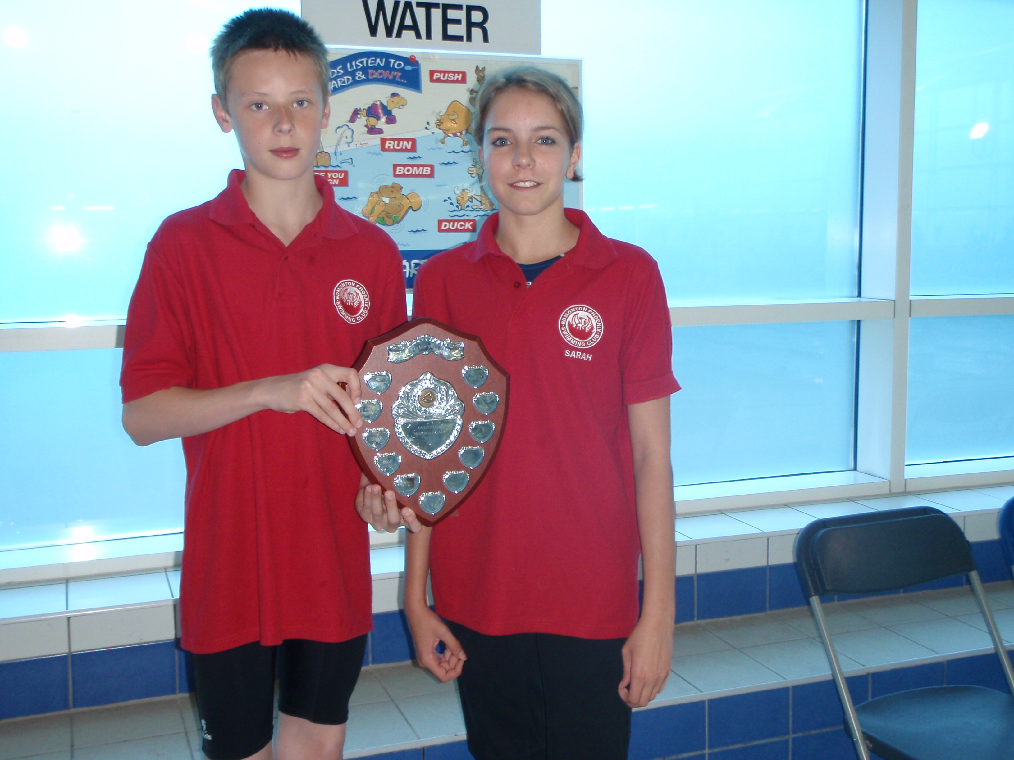

EDMONTON PHOENIX SC

Goldstone memorial gala

Edmonton Phoenix enjoyed a successful first entry into the Goldstone Memorial Gala.
The gala, hosted by Welwyn Garden SC was held at the Hatfield Swim Centre on the 30th of May 2009.

The pool presented an interesting proposition as it measures 33m in length, a challenge some of our younger swimmers would not have faced before. The gala comprised of a series of one length, two length and mixed relays, with ages from 9years to open swimmers.

We were competing against Borehamwood, Broxbourne, Welwyn Garden, Cheshunt and Hatfield. The gala started well and after 12 races we were in first place with Broxbourne and Welwyn Garden proving to be our strongest opposition. By race 24 we had slipped to second behind Broxbourne after which we traded places a couple of times before moving into the lead from race 38 where we stayed for the final 5 races. We eventually won by 11 points from Broxbourne with Welwyn Garden third, Cheshunt fourth, Hatfield fifth and Borehamwood sixth.

After some negotiation Frank avoided taking a dip in the pool. Sometimes our swimmers are too kind!

It was a fantastic gala, well run in a nice environment and against some friendly clubs. The swim team were great and they all swam really well, giving 100% effort and creating a strong team spirit. It really was a day to savour and one where it was a real pleasure to be associated with Edmonton Phoenix.

THE TEAM
Amy Sullivan, Caitlin McCabe, Lucy Sullivan, Rhiannon Ellis, Emily Whale, Maria Morgan, Mia Hawkes, Afton Doe, Amy Carson, Taria Carson, Connie Hawkes, Rachel Harris, Bethany Doe, Sarah Browne.

Callum Dodds, Andrew Camilo, Matthew Morgan, Josh Branch, Joe Glazebrook, Michael Buckley, Sam Fagg, Thomas Disney, Mark Morgan, Jesse Taylor, Ohio Dudu-Orumen, Stephen Cowley, Daniel Fellows.

WELL DONE EDMONTON PHOENIX!

