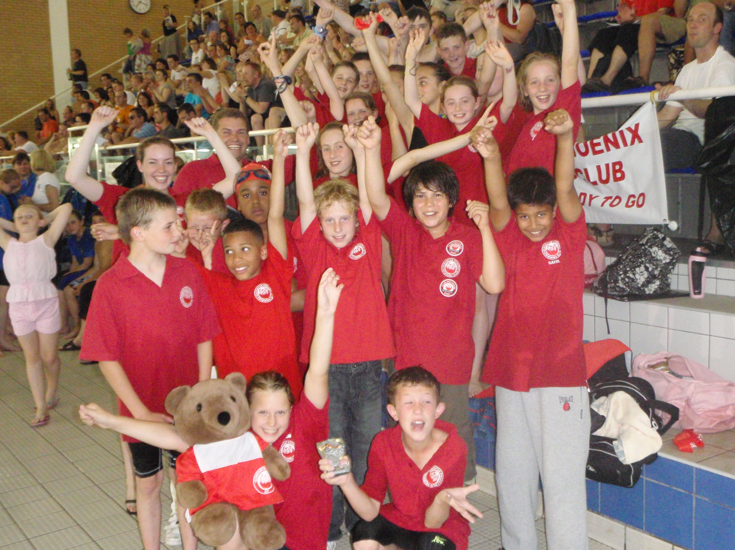

junior swimming league m11 round 3

Edmonton Phoenix competed in the final of the National Junior Swimming League Division 2 held at Southbury Leisure Centre on Saturday 28th of June, 2009.

A first and third place finish in the previous two rounds had qualified us for the final, ahead of 13 other clubs. Reaching the final was a massive achievement for the team and as we were up against Camden Swiss Cottage, Chelmsford, Rochford, Greenwich Borough Mariners and Erith, all very big clubs, it was going to be difficult to improve on our fifth place ranking.

Unfortunately illness had robbed us of the 9 year girls relay team but we had a steady start and we were consistently finishing in the middle positions for each race. Slippage problems for Joe Glazebrook in the trunk department and Amy Halihan in the goggle department meant that some points slipped away but the team kept fighting for every point. There were notable results for the relay team of Ben Howe, James Whiting, Josh Kirlew and Tom Newman who finished second in the 10 and under freestyle and medley relays, Tom Newman came second in the 10 years breaststroke, Josh Kirlew finished first in the 9 years backstroke and butterfly, Thomas Disney finished second in the 12 years and under breaststroke, Mia Hawkes finished first in the 10 years backstroke and second in the freestyle and Charlotte Newman finished second in the 12 years and under backstroke. The team as a whole were great, swimming their best and supporting each other.

At the end of the gala we were unable to improve on our fifth place ranking finishing ahead of Erith but behind Camden Swiss Cottage, Chelmsford, Greenwich Borough Mariners and Rochford. This meant that we finished fifth in the overall league standings. It was a very successful first entry as a single club in the National Junior Swimming League and hopefully we can build on this and push for promotion next year.

The Team
Charlotte Newman, Sydney Taylor, Parris Wilkinson, Bethan Holder, Michael Buckley, Thomas Disney, Joe Glazebrook, Sam Fagg, Amy Sullivan, Ellie Morgan, Andrew Camilo, Calum Middleton, Josh Kirlew, Sahil Shah, Emily Whale, Amy Halihan, Mia Hawkes, Savannah Wilkinson, James Whiting, Tom Newman, Ben Howe, Noah Duodoo, Michael Gargaro, Jade Mehmet Ali, Afton Doe, Amy Carson.

GO PHOENIX!

